 | IQVIATM Work Instruction Statistical Output
Document Number and Revision:
CS_WI_BS014 Revision 16
Document Owner:  Carrie Eason | Author(s):  Ramesh Yedlapally

PURPOSE
To describe the planning, production, review, delivery, documentation and archival of statistical output (Tables, Listings and Figures (TLFs)).

SCOPE

  - This work instruction (WI) applies to all projects globally where IQVIA Biostatistics produces statistical output (TLFs) using either SAS or non-SAS tools for internal or external customers.

ROLES AND RESPONSIBILITIES FOR QC OF THE TABLE SPECIFICATION
The following roles perform tasks described within this WI:

Role | Sections
Statistical Team Leader (STL) | 6.1, 6.2, 6.3, 6.4, 6.5, 6.6
Programming Team Leader (PTL) | 6.1, 6.2, 6.4, 6.5, 6.6
Biostatistics Project Team Member (BPTM) | 6.1
Programmer (Prog) | 6.1, 6.2
Quality Control Reviewer (QC) | 6.1, 6.3
Senior Biostatistical Reviewer (SB Reviewer) | 6.1, 6.3
The Prog role refers to both Production and Quality Control Programmers.
The QC role can be any appropriate reviewer (statistician or programmer) who has the necessary QC knowledge.

DEFINITIONS
Not Applicable

MATERIAL AND EQUIPMENT
Not Applicable

PROCEDURE

The workflow diagrams for this work instruction are presented in the Appendices.

Page 1 of 13
Copyright © 1999, 2000, 2003, 2006, 2008-2010, 2012, 2013, 2015, 2017, 2019, 2020, 2022 IQVIA. All rights reserved. The
contents of this document are confidential and proprietary to Quintiles IMS Holdings, Inc. and its subsidiaries. Unauthorized use, disclosure or reproduction is strictly prohibited.

Also refer to Interim Analyses (CS_WI_BS009) when producing statistical output (TLFs) as part of an unblinded (partial or complete) interim analysis (including those for Data Monitoring Committees [DMCs]) on an otherwise ongoing blinded study, if appropriate.

The six main steps involved in the creation of statistical output (TLFs) are:
- Planning (including the creation, review and maintenance of table specifications)
- Production
- Review (including quality control)
- Delivery
- Documentation
- Archival

  - Planning
Draft statistical output (TLFs), including dry runs, sent to the customer are regarded as official deliverables and must follow the same process as for the final deliverable, unless otherwise specified in the Biostatistics QC Plan (CS_TP_BS002).
Statistical output planning includes the creation, review and maintenance of output specifications or shells. The process for the creation and review of TLF shells is described in Statistical Analysis Plans (Covering Table Shells) (CS_WI_BS005).

No: | Who: | Step: | When:
6.1.1 | STL/ PTL | Creates the Tracking Document for Derived Datasets and Statistical Outputs (CS_TP_BS011) or applicable Biostatistics web-based solution/system. Creates a unique row for each statistical output. | Before commencing  statistical output programming
6.1.2 | STL | Identifies the need for table specifications.  Table specifications are created for each table output to describe the mapping of derived data to the tables. Specifications are considered optional for listings and figures and the table specification template options (CS_TP_BS023 or CS_TP_BS024) should be used if creating specifications for listings and figures.  There may be instances where a table specification is not required for all planned tables. Table specifications may be omitted for:  - Outputs generated by IQVIA Early Clinical Development (ECD) Biostatistics:  - Tables are either standard, simple and/or sourced from standard Analysis Data Model (ADaM) and Study Data Tabulation Model (SDTM) variable names and derivations  - Phase I Biostatistics TLF Templates are used to guide the programming of output instead. These templates are found | Before commencing statistical output programming

No: | Who: | Step: | When:
in the ELVIS folder: Global Biostatistics \ Processes \ GBIOS Processes – Implementation Guides and Templates
\ Phase I
- Simple tables (to be agreed with the BPTMs). The option of omitting table specifications is the exception, not the rule, and must be the result of reasoned assessment by the BPTMs only after considering:
  - The experience level of the BPTMs with the applicable table content
  - The complexity of the table(s) in question
  - The global dispersion of the BPTMs. Table specifications may be needed as a communication tool even for simple tables if the Programmer (or designee) and author of the table specifications are not co-located at the same site

If the choice is made to omit table specifications for select tables:
- Enters “N/A” in the “Spec Initials” column of the Tracking Document for Derived Datasets and Statistical Outputs (CS_TP_BS011) or applicable Biostatistics web-based solution/system to record which tables will not have an associated table specification
- Records the reason for omission of a table specification in the “Spec Name” column of the Tracking Document for Derived Datasets and Statistical Outputs (CS_TP_BS011) or applicable Biostatistics web-based solution/system to record the reason for each relevant table.
6.1.3 | STL/ PTL | Determines the layout option of table specifications to be used:  - Table Specifications – Shell Option (CS_TP_BS023) or  - Table Specifications – Spec Option (CS_TP_BS024)  Note: Create a written Table Specifications – Spec Option (CS_TP_BS024) instead of an Annotated Table Shell, Table Specifications – Shell Option (CS_TP_BS023) when the production of the statistical output (TLFs) is complex and/or an Annotated  Table Shell Table Specifications – Shell Option (CS_TP_BS023) is not adequate. | Before commencing statistical output programming
6.1.4 | STL/ PTL | Produces the table specifications guided by:  - Statistical Analysis Plan (SAP)  - Non-annotated TLF Shells  - Annotated Case Report Form (CRF)  - Non-CRF Data Guidelines  - Customer standards  - Customer instructions  - Internal customer (e.g. Project Medical Writer) requests  - Derived Dataset (DD) Specifications  - Relevant articles or literature | Before commencing statistical output programming

No: | Who: | Step: | When:
Produces table specifications that:
- Use the DD Spec as a basis or source for the table spec
- Do not include formulae. If needed, reference a formula in the applicable section of the Statistical Analysis Plan (CS_WI_BS005, Statistical Analysis Plans (Covering Table Shells))
6.1.5 | PTL /Prog | - Assigns the reviewer and enters the reviewer’s initials in the Tracking Document for Derived Datasets and Statistical Outputs (CS_TP_BS011) or applicable Biostatistics web- based solution/system.  - Documents in the QC plan if QC of the specifications is not required.  Note: If both the Programmer and QC Programmer use the table  specification as a source for programming a QC review of the table specification is to be performed. | Before commencing statistical output programming
6.1.6 | QC | Checks the assigned table specifications that have been identified as requiring QC according to:  - Approaches to QC (CS_WI_BS015)  - Biostatistics QC Plan (CS_TP_BS002)  - Approaches to QC Appendices documents Appendix I: Quality Gates for Tables, Figures and Listings (CS_OD_BS0228), Gate 1  Provides comments to the author of the table specification using the Reviewer Feedback Form (CS_FM_BS007) or applicable Biostatistics web-based solution/system if needed.  Enter the current date in the Tracking Document for Derived Datasets and Statistical Outputs (CS_TP_BS011) or applicable Biostatistics web-based solution/system when Quality Gate Checks are complete. | Before commencing statistical output programming
6.1.7 | STL | - Determines the need for SBR of the table specifications and, if required, flags specifications requiring SBR in the Tracking Document for Derived Datasets and Statistical Outputs (CS_TP_BS011) or applicable Biostatistics web- based solution/system.  - Documents in the QC plan if SBR of the specifications is not required.  Note: If a specification includes a statistical testing/modelling component, SBR is to be performed. | Before commencing statistical output programming
6.1.8 | SB  Reviewer | Reviews any table specifications that have been flagged as requiring SBR according to: | Before commencing

No: | Who: | Step: | When:
 |  | - Approaches to QC (CS_WI_BS015)  - Biostatistics QC Plan (CS_TP_BS002)  Completes a Reviewer Feedback Form (CS_FM_BS007) or applicable Biostatistics web-based solution/system to document formal review. | statistical output programming
6.1.9 | STL/ PTL | Takes responsibility for ongoing maintenance of the table specifications as follows:  - Updates the table specifications during the production and review of the statistical output (TLFs)  - Implements version control of the tables specifications as required when the statistical outputs (TLFs) are sent to the customer, or the table specifications are the deliverable  - Documents change to new versions of the table specifications in the “Modification History” section of the table specifications template (CS_TP_BS023 – Table Specifications - Shell Option, CS_TP_BS024 – Table Specifications - Spec Option)  - Follow additional naming and dating conventions as per General and Trial Master File (TMF)-Specific Document Quality – Good Documentation Practices (CS_WI_RM0284) | Before commencing statistical output programming for each separate deliverable  Ongoing through the production cycle

  - Production of Statistical Output
Refer to Section 6.1.4 for the documents / items that can guide the creation of the statistical output (TLFs). The production of statistical output (TLFs) requires the programming of the output by two independent programmers. The two outputs are then compared and reviewed per Section 6.3. The output creation steps listed below are completed by both programmers before moving on to the review step.

No: | Who: | Step: | When:
6.2.1 | STL/ PTL | Assigns programmers to output production and enters programmer initials in the Tracking Document for Derived Datasets and Statistical Outputs (CS_TP_BS011) or applicable Biostatistics web- based solution/system upon assignment. | Before commencing statistical output programming for each separate deliverable
6.2.2 | Prog | If the programmer is not the specification author and will be using the table specification, review the table specification during production of the statistical output program. Initiates a discussion with the author of the table specification and the PTL if there are items that require further clarification to facilitate programming. If the PTL is the table specification author, obtain additional input from STL. | Ongoing during statistical output programming

No: | Who: | Step: | When:
 |  | For outputs generated by ECD Biostatistics, review the output shells, and initiate a discussion with the STL if clarification is needed to facilitate programming of the output.
6.2.3 | Prog | Writes statistical output programs based on the following  - SAP  - Table specifications (or TLF Shells) and derived datasets  - Good Programming Practices documentation  - Current programming tools from Biostatistics Innovation available under the Biostatistics Tools in ELVIS  - Biostatistics Directory Structure  Note: If imputations are performed, the pre- and post-imputation data changes should be saved to a retrievable dataset for review. If subject selections (other than defined analysis sets) are performed, the subjects selected for analysis should be saved into a retrievable dataset for review. | During statistical output programming
6.2.4 | Prog | Identifies data issues that need to be resolved or explained and uses the Data Issues Log (CS_TP_BS014) or applicable Biostatistics web-based solution/system to communicate issues to the Data Transfer Lead (DTL) or (designee).  Note: A single Data Issues Log (CS_TP_BS014) or applicable Biostatistics web-based solution/system should be used for communication and resolution of data issues throughout the life of the study. | During statistical output programming
6.2.5 | Prog | Tests each output program (programmer’s review of their own work):  - Follows Approaches to QC (CS_WI_BS015)  - Follows Approaches to QC Appendices documents Appendix I: Quality Gates for Tables, Figures and Listings (CS_OD_BS0228), Gate 2  - Verifies that output/logs are created for all programs used in creation of statistical output (TLFs)  Shares unresolved warnings present in the SAS logs and warnings of a statistical nature (or equivalent for other analysis software) with the STL and SB Reviewer for further investigation. | Before statistical output is Ready for QC and ongoing through the production cycles
6.2.6 | Prog | Maintains the output programs in accordance with table specification (or TLF Shell) updates or review comments:  - Review the modification history of the table specifications (or TLF Shell) to ensure all applicable updates are incorporated into the programs  - Repeat gate checks in Approaches to QC (CS_WI_BS015) related to modifications  - Document changes to new versions of the table specifications in the “Modification History” section of the Programs once version control is implemented | During the production of statistical output and ongoing through the production cycles

No: | Who: | Step: | When:
 |  | - For outputs generated by ECD Biostatistics, if the programmed version of outputs differs significantly from the specific output shell(s) then initiate a discussion with the customer to document the change in a SAP addendum or in Change from Planned Analyses section of the CSR as appropriate
6.2.7 | Prog | Updates and maintains the “Overall Status” in the Tracking Document for Derived Datasets and Statistical Outputs (CS_TP_BS011) or applicable Biostatistics web-based solution/system when the Quality Gate Checks are completed for each Statistical Output. | Ongoing during statistical output programming
6.2.8 | STL/ PTL | Implements version control for the output program when sent to a customer (Internal or External) as part of a deliverable per Section 6.5. | Ongoing during statistical output programming

  - Review of Statistical Output
Before sending any statistical output (TLFs) to the customer, the following reviews must be completed:
    - A QC Review
    - A Statistical Team Lead (STL) Review
    - A Senior Biostatistical Review

An individual can perform more than one of these review stages if it does not compromise the independence of review (e.g., STL can perform QC review and STL review).

No: | Who: | Step: | When:
6.3.1 | QC | Checks the statistical output according to:  - Approaches to QC (CS_WI_BS015)  - Approaches to QC Appendices documents Appendix I: Quality Gates for Tables, Figures and Listings (CS_OD_BS0228), Gate 3  Updates the Tracking Document for Derived Datasets and Statistical Outputs (CS_TP_BS011) or applicable Biostatistics web-based solution/system when the Quality Gate Checks are completed for each statistical output.  Requests input from an independent statistician where independently programmed outputs do not compare, and the reasons need to be investigated. | Statistical Output is Ready for QC
6.3.2 | STL | Reviews the statistical output (TLFs) according to:  - Approaches to QC (CS_WI_BS015) | Prior to SBR and before sending

No: | Who: | Step: | When:
 |  | - Approaches to QC Appendices documents Appendix I: Quality Gates for Tables, Figures and Listings (CS_OD_BS0228), Gate 4  Updates the Tracking Document for Derived Datasets and Statistical Outputs (CS_TP_BS011) or applicable Biostatistics web-based solution/system when the Quality Gate Checks are completed for each statistical output. Completes a Reviewer Feedback Form (CS_FM_BS007) or applicable Biostatistics web-based solution/system to document the review. | statistical output to the customer
6.3.3 | SB  Reviewer | Reviews the statistical output (TLFs) according to:  - Approaches to QC (CS_WI_BS015)  - Approaches to QC Appendices documents Appendix I: Quality Gates for Tables, Figures and Listings (CS_OD_BS0228), Gate 5  Completes a Reviewer Feedback Form (CS_FM_BS007) or applicable Biostatistics web-based solution/system to document the review. | Before sending statistical output to the customer

  - Delivery of Statistical Output

No: | Who: | Step: | When:
6.4.1 | STL/ PTL | - Agrees with the customer as to whom, including internal IQVIA staff, will receive the output and when the delivery is to take place.  - Considers that some sets of output, e.g., top-line tables, may be delivered to a reduced set of recipients.  - In view of the need for customer confidentiality, determines the delivery method for the output:  - Ideally outputs will be placed on a secure server accessible only by IQVIA and the customer.  - If sending output via email:  - Use encryption on emails when statistical outputs are sent via email.  - Password protect email attachments without exception.  - Open the attachment prior to sending and verifies it is the correct deliverable.  - Do not use the same email distribution list to send the password as was used for the output.  - Send the password to exactly one person within the recipient organization using a new email chain. Asks that person to distribute the password as needed within the recipient organization | When sending statistical output to the customer

No: | Who: | Step: | When:
 |  | - Send the password to IQVIA staff copied on the output in a new, separate email chain.

  - Documentation
Study Team Members involved in the creation or review of statistical output (TLFs) and Table Specifications must store electronic files according to the Biostatistics Directory Structure and/or in the eTMF as appropriate.

No: | Who: | Step: | When:
6.5.1 | STL/ PTL | Completes a customer Authorization Form (CS_FM_BS002) or equivalent documentation for each final delivery of statistical output (TLFs) or table specifications sent to an internal or external customer detailing the version number, version date and delivery contents. For final deliveries only made to internal customers, provide the authorization documentation to the internal customer. | As part of the delivery procedure
6.5.2 | STL/ PTL | Obtains signatures for the Tracking Document for Derived Datasets and Statistical Outputs (CS_TP_BS011) and Reviewer Feedback  Form (CS_FM_BS007) or the applicable Biostatistics web-based solution/system from all study team members as required. | As part of the delivery procedure
6.5.3 | STL/ PTL | Creates a “snapshot” of each delivery per Management and Filing of Biostatistics Documentation (CS_WI_BS0237) using the appropriate department tools e.g., Snapshot Tool.  For each customer deliverable (excluding Dry Runs), copies the latest version of the Data Issues Log in the “Deliveries” folder of the Biostatistics Directory Structure. | As part of the delivery procedure
6.5.4 | STL | Files the final documentation in the relevant folder(s) based on the TMF platform used per Trial Master File (TMF) (CS_OP_TMF0007) and Management and Filing of Biostatistics Documentation (CS_WI_BS0237). | After the delivery, within 30 days of finalization or on receipt

  - Archival

No: | Who: | Step: | When:
6.6.1 | STL/ PTL | Archives all documentation necessary for the reproduction of the output delivered to the customer, according to Management and Filing of Biostatistics Documentation (CS_WI_BS0237). | After finalization of statistical output

- SUPPORTING DOCUMENTATION
DOCUMENT NUMBER | TITLE
ESOP References
7.1 CS_FM_BS002 | Customer Authorization Form
7.2 CS_FM_BS007 | Reviewer Feedback Form

DOCUMENT NUMBER | TITLE
7.3 CS_OD_BS0228 | Approaches to QC Appendices documents Appendix I:  Quality Gates for Tables, Figures and Listings
7.4 CS_OP_TMF0007 | Trial Master File (TMF)
7.5 CS_TP_BS002 | Biostatistics QC Plan
7.6 CS_TP_BS011 | Tracking Document for Derived Datasets and Statistical Outputs
7.7 CS_TP_BS023 | Table Specifications - Shell Option
7.8 CS_TP_BS024 | Table Specifications - Spec Option
7.9 CS_WI_BS005 | Statistical Analysis Plans (Covering Table Shells)
7.10 CS_WI_BS009 | Interim Analyses
7.11 CS_WI_BS015 | Approaches to QC
7.12 CS_WI_BS0237 | Management and Filing of Biostatistics Documentation
7.13 CS_WI_RM0284 | General and Trial Master File (TMF)-Specific Document Quality - Good Documentation Practices
7.14 CS_TP_BS014 | Data Issues Log
External References
7.15 | Biostatistics Tools
7.16 | Good Programming Practices
7.17 | Biostatistics Directory Structure

- SUPERSEDES
DOCUMENT NUMBER | TITLE | REVISION NUMBER
8.1 CS_WI_BS014 | Statistical Output | 15

- MODIFICATION FROM PREVIOUS REVISION
CHANGE | SECTION REFERENCE | JUSTIFICATION
Added wording about the "applicable Biostatistics web- based solution/system" where the tracking document or reviewer feedback form is mentioned | Throughout | Process clarification
Text updated to refer to “SBR” for “Senior Biostatistical Review” and “SB Reviewer” for “Senior Biostatistical Reviewer” | Throughout | Clarity
Changed LP (Lead Programmer) to PTL (Programming Team Leader) | Throughout | For consistency across documentation

Minor formatting and vocabulary updates | Throughout | Consistency and clarity
Changed "Simple tables (only by agreement amongst the BPTMs)" to "Simple tables (to be agreed with the BPTMs)" | Section 6.1.2 | Clarity
Text updated to make it clearer that the QC to be performed is  the table specification | Section 6.1.5 | Process clarification
Added instructions on how to document when QC of the table specification is not  required | Section 6.1.5 | Process clarification
Added instructions on how to document when SBR of the table specification is not required | Section 6.1.7 | Process clarification
Updated text to make it clear that version control is to be used as appropriate on the table specifications when the TLF’s produced from the specifications, or the table specifications are delivered to a  customer | Section 6.1.9 | Process clarification
Updated text to give the Snapshot Tool as an example of the appropriate tool to use to create a delivery snapshot | Section 6.5.3 | Process clarification

- APPENDICES

  - Appendix A: Table Specifications Workflow

  - Appendix B: Statistical Output Workflow

Appendix A: Table Specifications Workflow

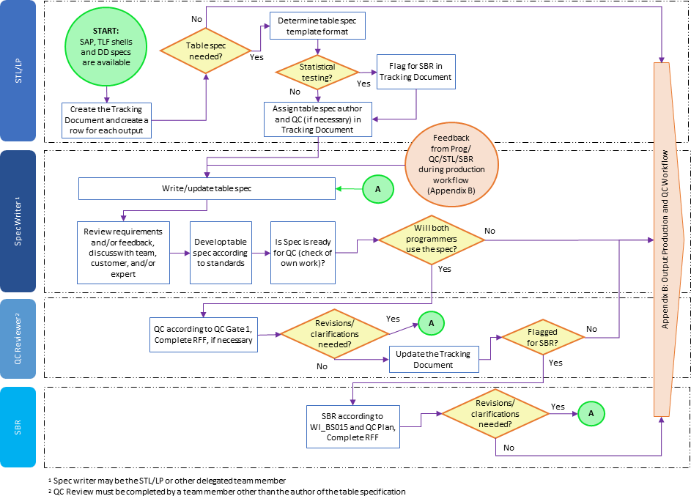

Appendix B: Statistical Output Workflow

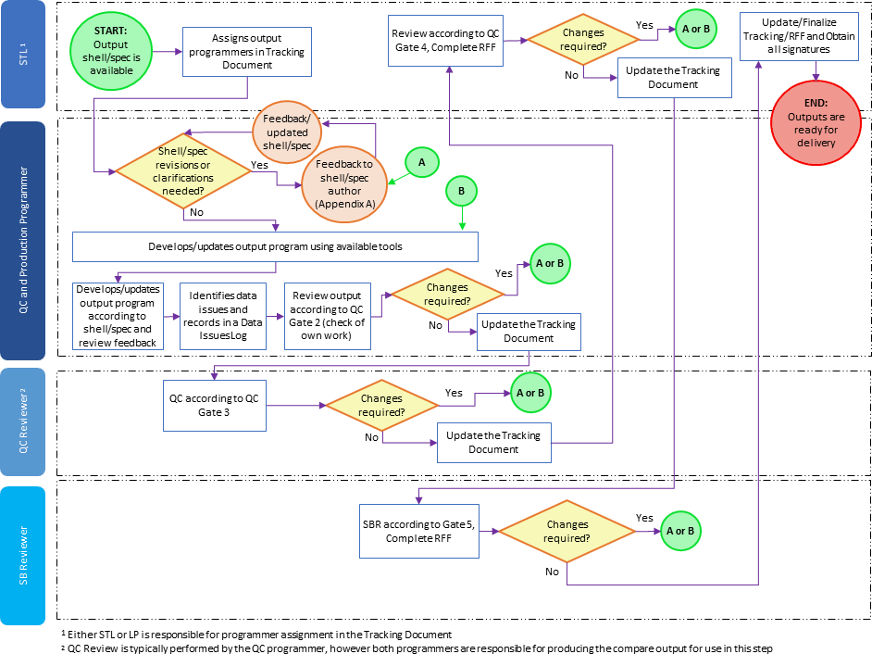

Page 13 of 13
Copyright © 1999, 2000, 2003, 2006, 2008-2010, 2012, 2013, 2015, 2017, 2019, 2020, 2022 IQVIA. All rights reserved. The
contents of this document are confidential and proprietary to Quintiles IMS Holdings, Inc. and its subsidiaries. Unauthorized use, disclosure or reproduction is strictly prohibited.

Standard Operating Procedure Approval Signature(s)
This is a representation of an electronic record that was signed electronically in Content Server.
This page is the manifestation of the electronic signature(s) used in compliance with the organization’s electronic signature policies and procedures
Refer to Signatories CV for Business Title.

UserName: Bickford, Emma (q637065) Title:
Date: Friday, 04 November 2022, 01:20 PM Eastern Daylight Time Meaning: Signing this Document Indicates My Approval
================================================

UserName: Ranjan, Santosh (q723916) Title:
Date: Friday, 04 November 2022, 03:07 PM Eastern Daylight Time Meaning: Signing this Document Indicates My Approval
================================================

